**Andre Oppong**

**My SQL Assignment**

***Screenshot of my SQL Assignment***

I went to the open a script file and opened the Create DB Store.

I opened the Create DB Store file on the Database script.

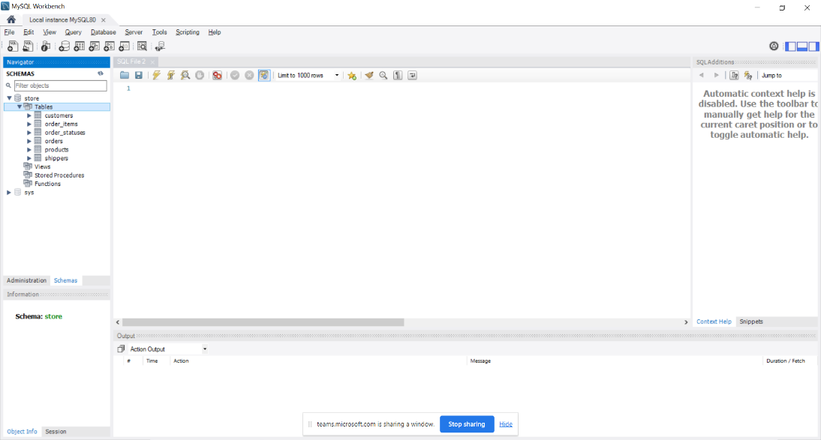

I clicked on the Schemas section to access the tables columns from the Navigator table.

In this image, I managed to click on the run query button to run my own database and the data came out positive.

As soon as I clicked on the Execute button, all the information including the customer_id, first name, last name, birth date, phone, address, city, state and points appeared on the results grids automatically.

I ascended the first name column by clicking on the first name tab.

But now, the first_name is in the ascending order, where it showed Ambur Roseburgh, Barbara MacCaffrey, Clemmie Betchley, Elka Twiddell, Freddi, Boagey, Ikene Dowson, Ines Brushfield, Levy Mynett, Rumgay and Thacher Naseby after spending 4 minutes or 5 minutes clicking on the #Arrange customer’s names in the ascending order.

I am highlighting the Fields- from Customer_id to birth date to copy and paste the results into the word document.

|  |  |  |  |
| --- | --- | --- | --- |
| **Customer ID** | **First Name** | **Last name** | **Birth Date** |
| 8 | Thacher | Naseby | 1993-07-17 |
| 9 | Romola | Rumgay | 1992-05-23 |
| 6 | Elka | Twiddell | 1991-09-04 |
| 2 | Ines | Brushfield | 1986-04-13 |
| 1 | Babara | MacCaffrey | 1986-03-28 |
| 3 | Freddi | Boagey | 1985-02-07 |
| 4 | Ambur | Roseburgh | 1974-04-14 |
| 5 | Clemmie | Betchley | 1973-11-07 |
| 10 | Levy | Mynett | 1969-10-13 |
| 7 | Ilene | Dowson | 1964-08-30 |

I copied and pasted those results from MY SQL-Results grid into the Word Document and those information contained customers date of birth.

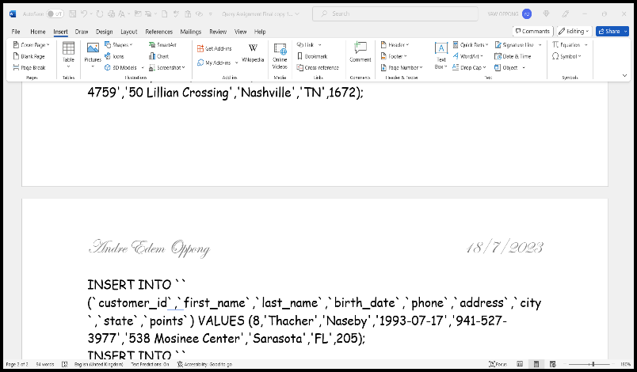

I recorded the date of birth 1990-01-01 of all the Customers in the Word Document.

I went to the Export Recordset Tab and exported customers table automatically.

I went to the Executed Statement button and the product ID, Quantity in stock and unit price information appeared automatically.

I recorded a copy of customers date of birth after spending 4 or 5 minutes clicking on the SQL Insert Statements in the Save as type option.

So far, I learnt how to convert Export Data from SQL Insert Statements to Word.

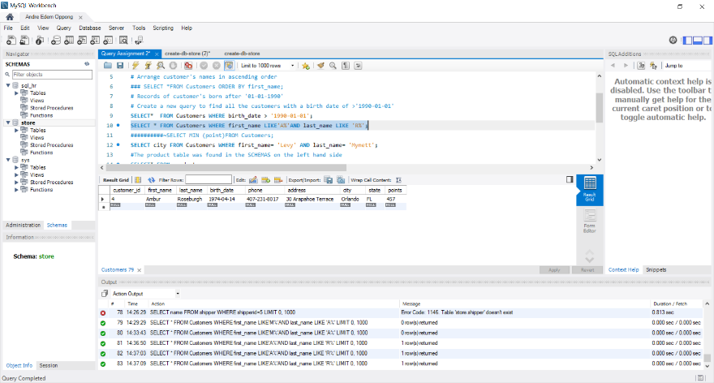Here’s the final version of t # customer_id, first_name, last_name, birth_date, phone, address, city, state, pointshe Customers Date of Birth.

I clicked on the code and changed the syntax from M to A in the first name and from M to R in the last name as well.

This means that Amber Roseburgh’s record automatically came up , when I pressed on the Execute button.

I exported Amber Roseburgh’s records and selected SQL Insert Statements in the save options.

When I saved my Query into my folder, the Export Recordset came up and named my table first name and last name for Amber's records.

I recorded Amber’s records into the Word Document from MY SQL Statement file.

I selected the Execute the statement option again and the min point came up again.

In addition, I also exported the Point 457 points from Amber’s score column and renamed the file Query Assignment 6 Points- SQL Insert Statements.

I typed up Points in the table name and exported the records.

Here’s a copy of the Min Point of Ambur Roseburgh’s points in the records that I created on my SQL Statement and it transferred into Word.

I typed up the “--There are—and SELECT MIN(points), MAX(points) FROM CUSTOMER;”😉 to create the syntax and min and max appeared on the fields, when I clicked on the Execute Statement button.

I am about to click on the Export recordset button to transfer the Customers min and max points into an external file to enable me to record the results in word.

Later on, I added Customers Points in the file name and selected SQL Insert statements to save it.

I added Customers Points in the table name, when the Export Recorded options appeared.

I had the right to transfer the Customers Min and Max Point from my SQL Workbench into the Word Document for recording.

I highlighted “SELECT city FROM Customers WHERE first_ name= ‘Levy AND last_name=’Mynett’; section, because I am about to press the execute button to run this query.